SIZZLE Real Photos
Linda (Fraud Dog) Age 4 with Father and Brother
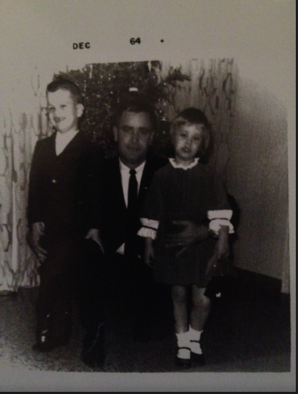
Linda’s Cop Years
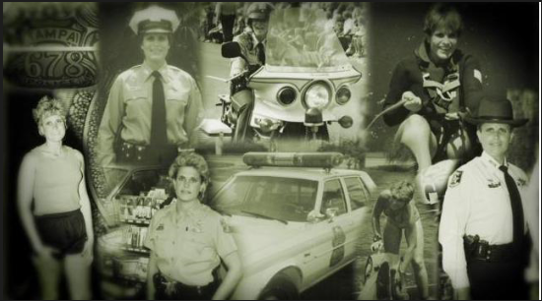

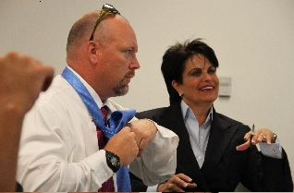
Linda Webb, and Mike Marks preparing on set

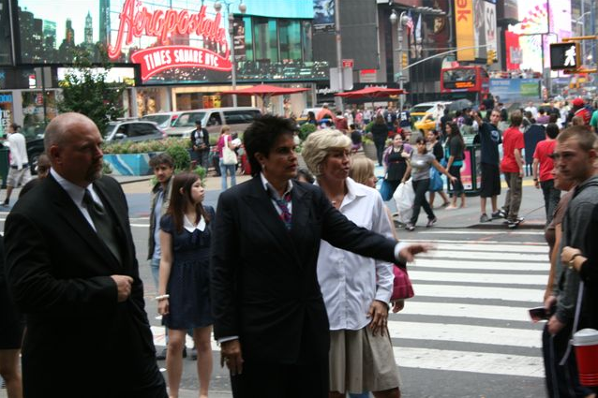
Linda Webb talking to the public in New York City, Times Square.
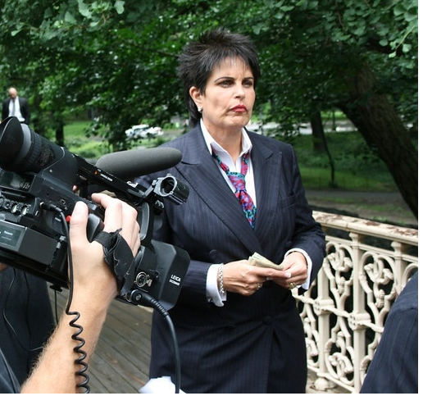
Linda Webb, Fraud Dog on set in New York City, Central Park
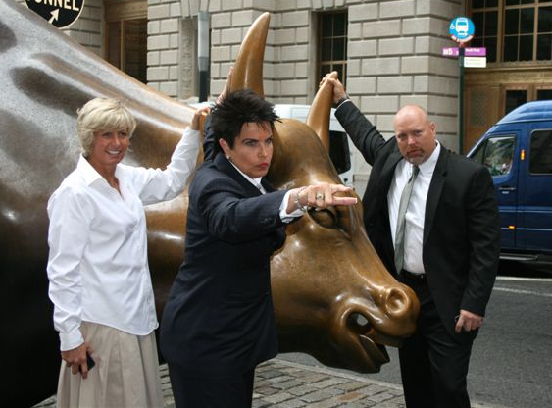

Linda Webb, Fraud Dog, and her team, Leigh Mills and Mike Marks, New York, Wall Street Bull

Linda saying…Fraudster, I’m coming for YOU!
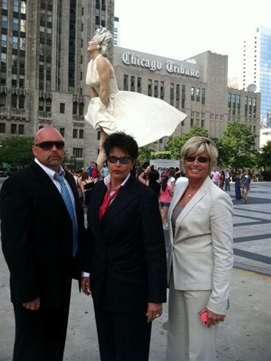

Linda Webb, Fraud Dog, and her team Leigh Mills and Mike Marks in downtown Chicago
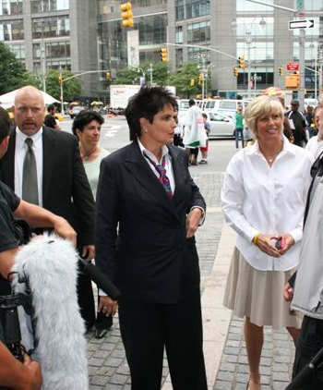
Linda Webb, Fraud Dog on set in New York City
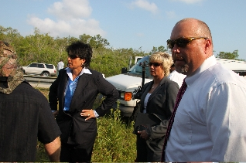
Linda Webb, Fraud Dog with her team on set in the Everglades, Florida
Linda Webb, Fraud Dog with her team on set in Palm Beach, Florida
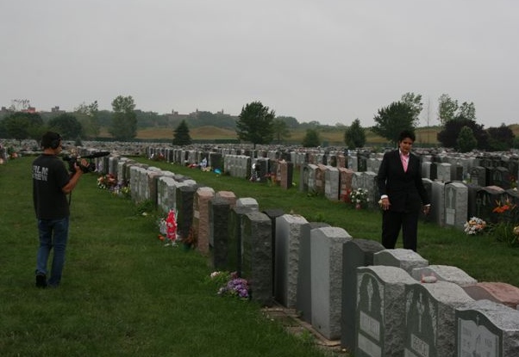

Linda Webb, Fraud Dog, filming in a cemetery in the Bronx, New York

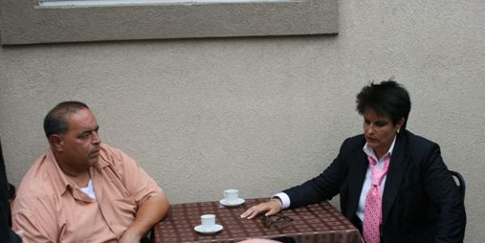

Linda Webb filming on set in New York

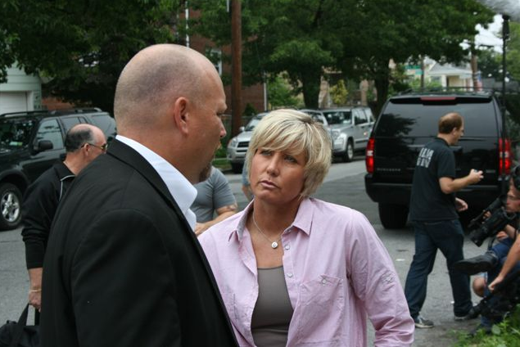
Linda’s fraud team, Mike Marks and Leigh Mills on set in Chicago, Florida
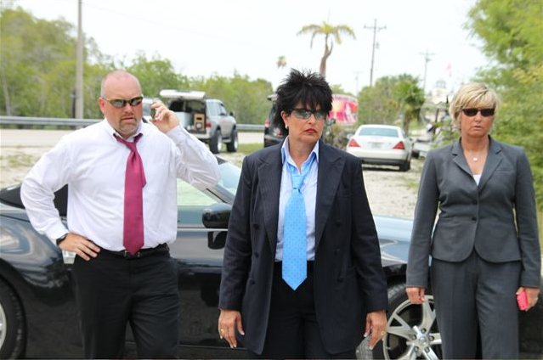
Linda Webb, Fraud Dog, and her fraud fighting team, Mike Marks, and Leigh Mills in the Everglades, Florida
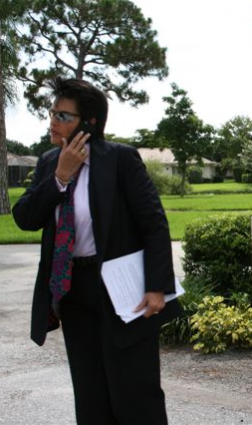
Linda Webb, Fraud Dog on set in Palm Beach Florida
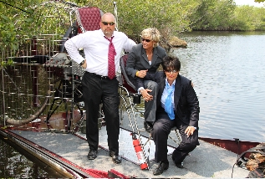

Linda Webb and her fraud fighting team on air boat in the Everglades, Florida

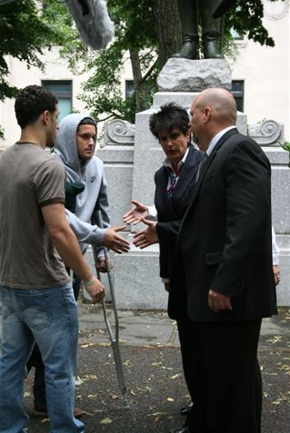
Linda Webb and Mike Marks with other actors on set in New York City Park
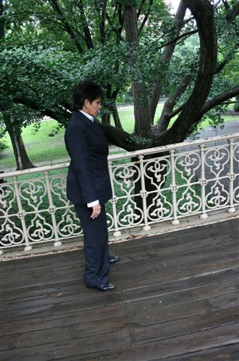
Linda Webb, Fraud Dog on set in Central Park, in New York City
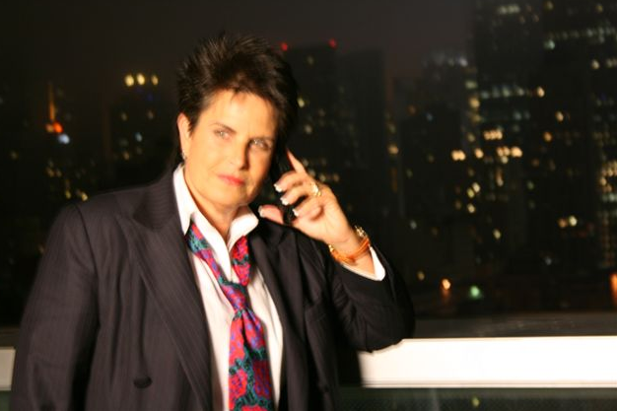Linda Webb, Fraud Dog on set on roof top of hotel in New York City
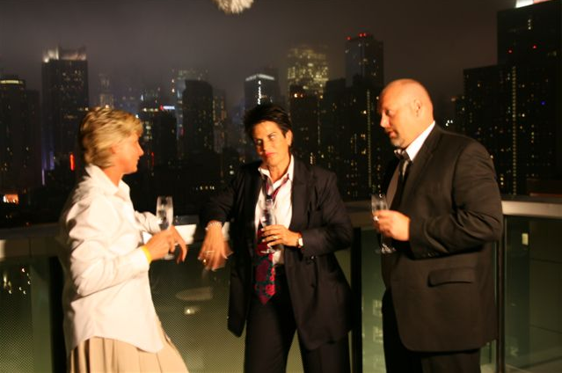
Linda Webb, Fraud Dog, with her fraud fighting team on set of rooftop hotel in New York City
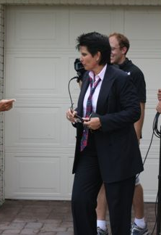

Linda Webb, Fraud Dog on set in Palm Beach, Florida

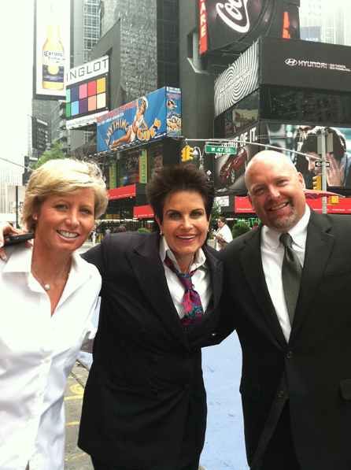
Linda Webb, Fraud Dog and her fighting team, Mike Marks and Leigh Mills
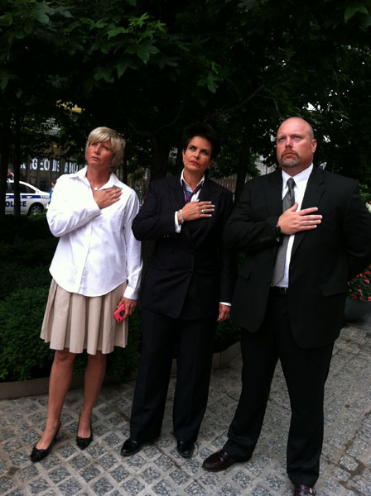
Linda Webb, Fraud Dog, with her team at the World Trade Towers Site
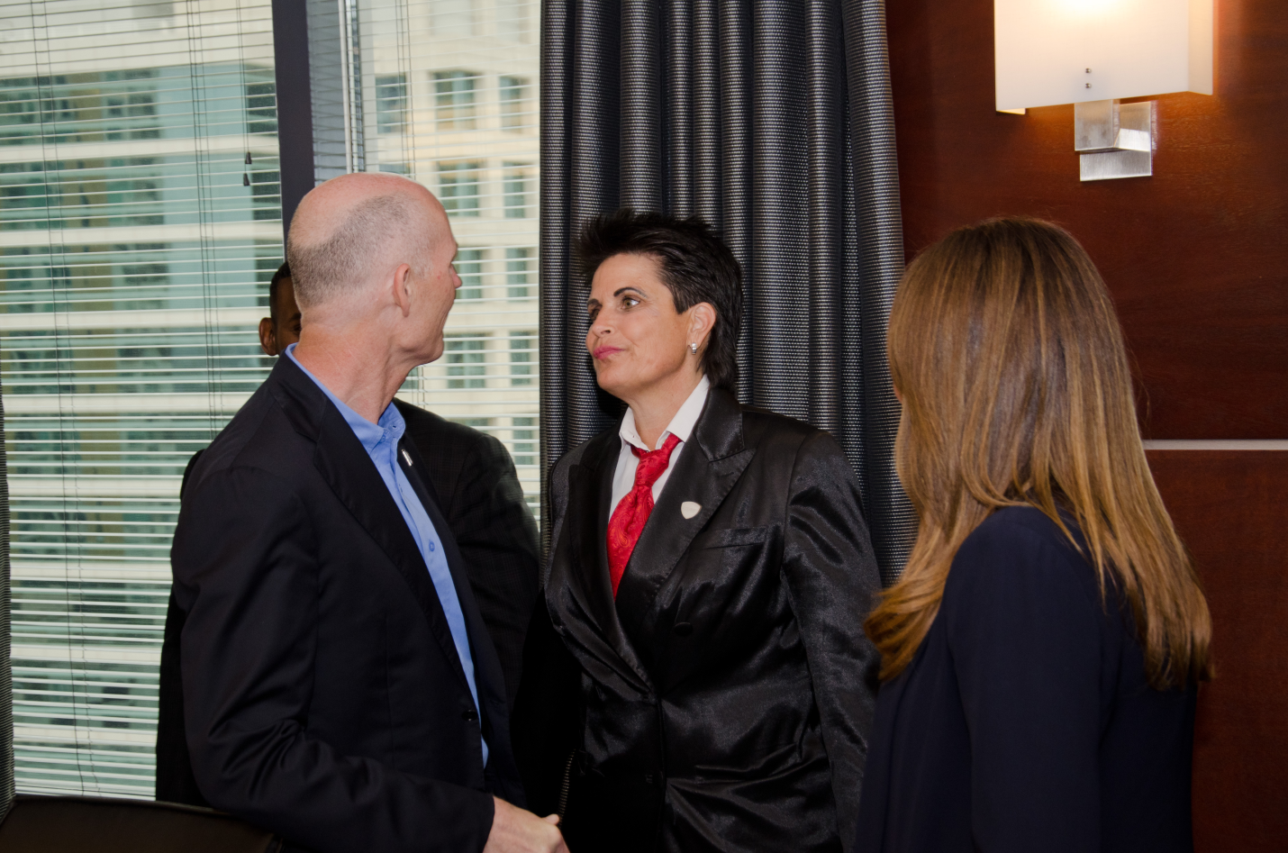
Linda talking with the State of Florida Governor
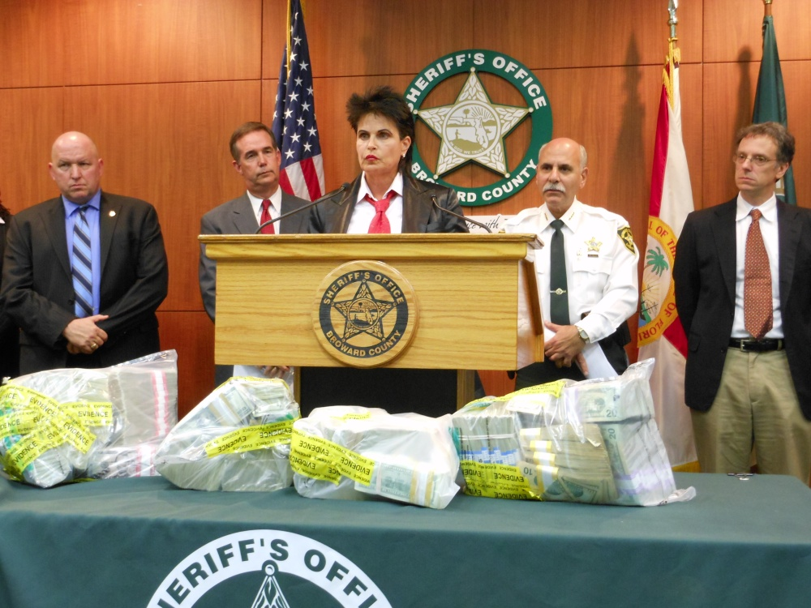
Linda Webb – At Press Release “Operation Dirty Money”
